Different Paths
Look at the pictures and talk about the questions below with your grown-up:
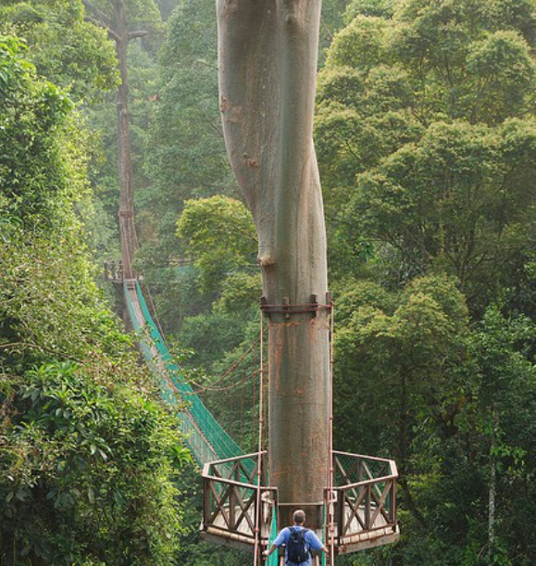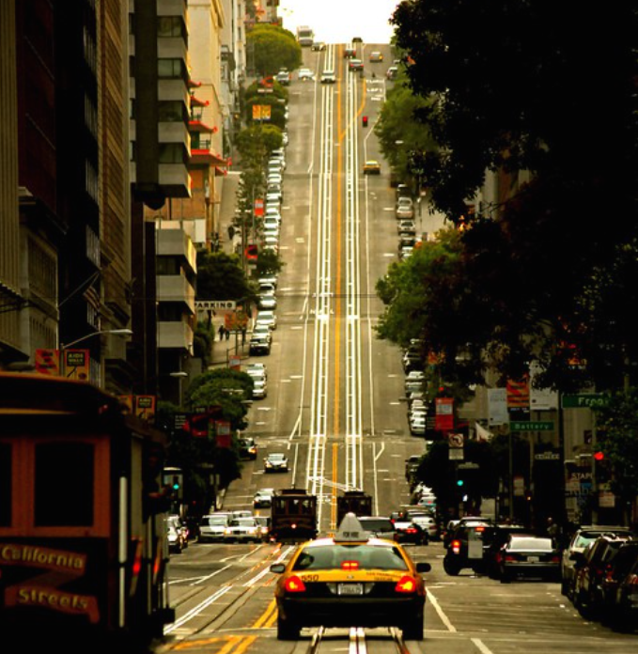
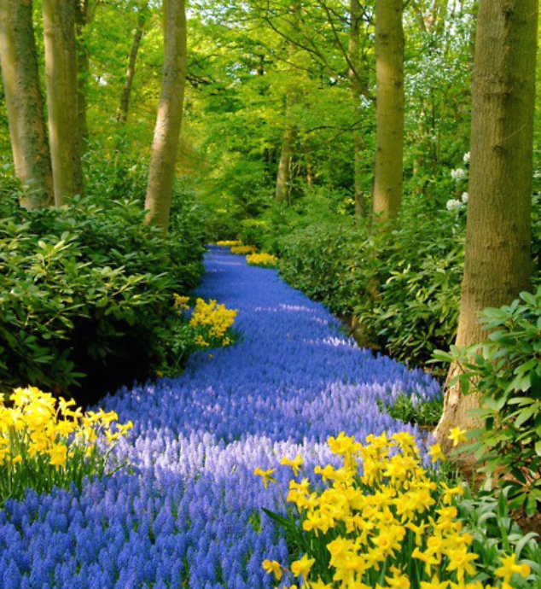
- Which road/path would you choose to travel along?
- Where do you think it is? Is it in the UK or somewhere else?
- Where might it go to?
- What/who might you see along the way?
- How would you feel travelling along there?
- What would you be travelling in? E.g. a bike, a car or on foot.
- What/who would you take with you?

