Tiny Dragon

Look at the picture and talk about the questions below with your grown-up:

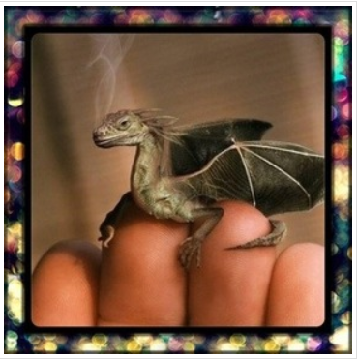

- Where is it from?
- Why is it so small?
- Where does s/he live?
- How will you look after it?
- What is it called? Is it magic? What magic can it do?

- I like to imagine that it is a really small dragon which you can keep in your pocket but when you need it to, it can grow really big so that you can ride on it.

