Friday 5th March – Sticky

Look at the picture and talk about the questions below with your grown-up:

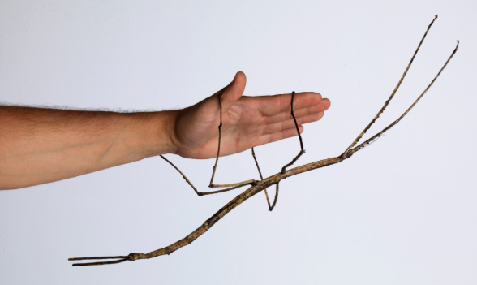

- What do you think this creature is?
- Why do you think it looks like this? Think about how looking like a stick might help it to stay safe.
- Would you like to hold one of these creatures? What do you think it might feel like?
- Would you like one of these creatures as a pet? Why/why not?
- This creature can be found on every continent except Antarctica. Why do you think that they don’t live in Antarctica?

